Final Mackerel Model Technical Details
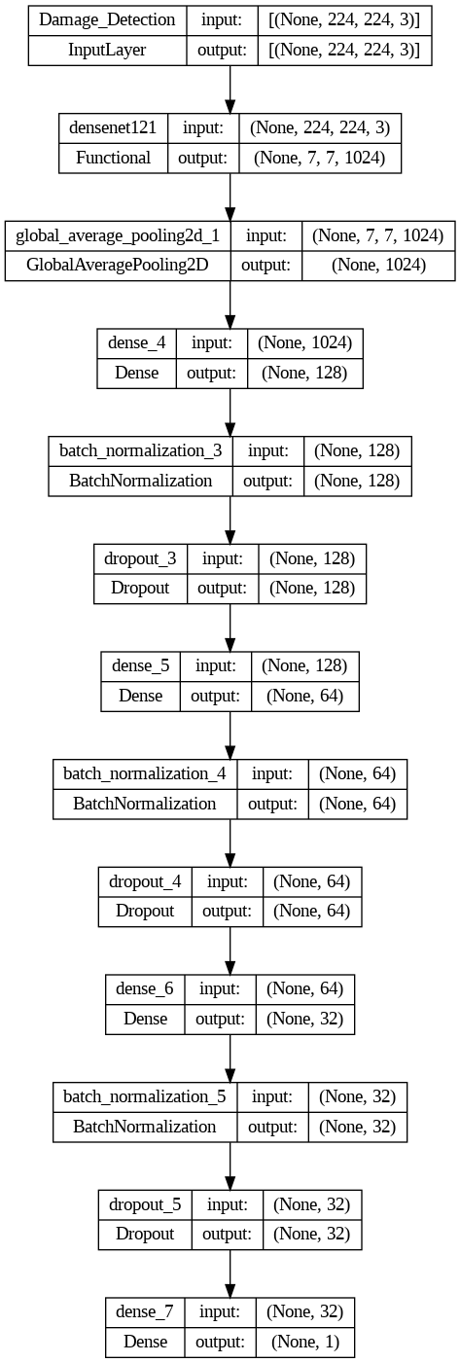
Model Architecture:
The final model (Version 14) integrates a two-stage approach for accurate fish classification and damage detection. It first employs a YOLOv8 model for damage detection, followed by the DenseNet121 convolutional neural network (CNN) for the final classification.

Damage Detected

Not detected

Bad

- Damage Detection (YOLOv8):
  - YOLOv8, from the Ultralytics library, is used for detecting visible damage or cuts on the fish's surface or skin. This image segmentation model, based on the Pytorch framework, detects areas where the fish may have visible damage, classifying those regions as "bad" or "damaged." If damage is detected on the fish surface, the fish is classified as "bad."
  - Segmentation: The model segments out the damaged portions of the fish and classifies the whole fish as "bad" if the damage is significant enough. Healthy fish with no visible damage are classified as "good."
- Classification (DenseNet121):
  - After the damage detection step, the segmented fish image is passed through the DenseNet121 CNN for final classification. DenseNet121 is highly efficient in handling image classification tasks due to its use of dense blocks, allowing for better feature reuse.
  - Dense Layers: Three fully connected layers with sizes 128, 64, and 32 neurons respectively.
  - Dropout Rates: The dropout rates for the dense layers are 0.4, 0.3, and 0.2, respectively, to reduce overfitting.
  - Activation Function: The output layer uses Sigmoid activation for binary classification (good/bad).
  - Loss Function: Binary Cross-Entropy loss, suitable for imbalanced binary classification tasks.
  - Metrics: F1-Score is used to evaluate the model, ensuring a balance between precision and recall for both classes.
Fine-Tuning:
During training, transfer learning was employed. Four out of the five blocks in the DenseNet121 model were frozen, and only the final block was set to train, leveraging pre-trained features for faster convergence and better accuracy.

Dataset Details
The dataset used to train the model includes images of fish, with a focus on classifying them as "good" or "bad" based on their freshness. This version incorporates the detection of damage on the fish surface to enhance classification accuracy.
- Data Augmentation: Applied to increase model robustness through techniques like rotation, zoom, shift, and changes in brightness and color.
- Image Type: Segmented images with black backgrounds were used for clearer analysis.
- Dataset Distribution:
  - Train: 22,726 images
  - Validation: 2,912 images
  - Test: 2,901 images
  - Unseen Test: 520 images
- Image Pre-processing:
  - Cropping: Fish images were processed by extracting the detected fish mask and padding the background with black pixels.
  - Resizing: All images were resized to 224x224 pixels to ensure uniformity.
  - Normalization: The DenseNet pre-process input function was used to normalize the image pixel values, transforming them into a range of 0 to 1 for better model convergence.
Classification Task:
The model classifies fish into two categories: "good" and "bad." Fish with visible damage on their surface or skin are classified as "bad," while those without such damage are classified as "good."

Results
The final model (Version 14) demonstrated strong performance when evaluated on both the test set (part of the train-test split) and unseen field data. The results from both the validations are as follows:
- Test Set Validation (Part of the Train-Test Split):
  - Accuracy: 0.89
  - Precision:
    - Good fish: 0.90
    - Bad fish: 0.87
  - Recall:
    - Good fish: 0.91
    - Bad fish: 0.85
  - F1-Score:
    - Good fish: 0.90
    - Bad fish: 0.86
  - The model performed well in classifying both "good" and "bad" fish, with a high precision and recall for the "good" class (0.90 and 0.91, respectively). The "bad" class also showed good performance with a precision of 0.87, but the recall was slightly lower (0.85), indicating that some "bad" fish were not detected.
- Unseen Data (Field Test):
  - Accuracy: 0.97
  - Precision:
    - Good fish: 1.00
    - Bad fish: 0.12
  - Recall:
    - Good fish: 0.97
    - Bad fish: 1.00
  - F1-Score:
    - Good fish: 0.99
    - Bad fish: 0.22
  - The model showed near-perfect performance in identifying "good" fish, with a precision of 1.00 and a recall of 0.97. However, the "bad" class showed very low precision (0.12), meaning that the model had trouble distinguishing "bad" fish from "good" fish in the field test. Despite this, the recall for "bad" fish was perfect (1.00), indicating that when a "bad" fish was detected, it was classified correctly. This suggests that the model might have a high number of false positives for "bad" fish in field conditions.

